Short Profile of Dr. C. Anandharamakrishnan
Dr. C. Anandharamakrishnan  Senior Principal Scientist  Department of Food Engineering  CSIR-Central Food Technological Research Institute,  Mysuru, Karnataka 570020  ----------------------------------------------------------------------  Former Director  National Institute of Food Technology, Entrepreneurship and Management - Thanjavur  anandhram@cftri.res.in  c.anandharamakrishnan@gmail.com  .  Orcid ID 0000-0002-9599-5594  Scopus ID 16548780200  Researcher ID AAP-8096-2020 | 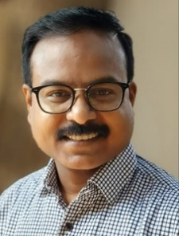  www.anandharamakrishnan.com

Areas of Specialization
The research work involves the application of principles of food engineering for process and product development in the following areas:
- Food nanotechnology (established India’s first center for food nanotechnology at CSIR-CFTRI);
- Engineered stomach and intestinal system (which is Asia’s first system of this kind, primarily for nutrient bioavailability and glycemic index studies);
- 3D food printing (India’s first indigenous 3D food printing equipment developed including India’s first scientific publications in this field)
- Computational Fluid Dynamics (CFD) modeling of food processing operations (established the country’s first research group on this area at CSIR-CFTRI and the country’s first scientific publications in this field);
- Micro and nano encapsulation of food bioactives and functional ingredients using spray drying, spray-freeze-drying, electrospinning and electrospraying processes (India’s first indigenous spray-freeze-drying rig was developed; also, India’s first scientific publications in this field).

Honors/ Awards/ Recognitions Received
- Adjunct Professor at Institute of Chemical Technology (ICT), Mumbai (from 2019).

Fellows of National & International Academies/Bodies
- Fellow of National Academy of Sciences (FNASc - 2019)
- Fellow of National Academy of Agricultural Sciences (FNAAS - 2019)
- Fellow of Royal Society of Chemistry, UK (FRSC - 2016)
- Fellow of Association of Food Scientists & Technologist of India (FAFSTI - 2017)
- Fellow of Royal Society of Biology, UK (FRSB - 2018)
- Fellow of Institute of Engineers of India (FIE - 2013)

International Fellowship

- 2004 - 2008 - Commonwealth Scholarship/ Fellowship Programme, Government of United Kingdom, for the work at Loughborough University, United Kingdom

National and Institutional Awards

- ICAR - Rafi Ahmed Kidwai Award of Indian Council of Agricultural Research (ICAR) - 2019
- Department of Biotechnology (DBT) – Tata Innovation Fellowship 2019-20
- Ranked as TOP 2% of Scientists working in the field of Food science and Technology by Stanford University and Elsevier in 2022.
- NASI – Reliance Industries Platinum Jubilee Award 2018 for application-oriented innovations in the field of biological sciences
- National Design Award in Environmental Engineering 2019 by The Institution of Engineers, National Design and Research Forum.
- Tamil Nadu Scientist Award-2018 in the category of Engineering and Technology by Government of Tamil Nadu
- All India Food Processors’ Association (AIFPA) Special Platinum Jubilee Award for Development of Food Processing Technology and Innovation-2018.
- Alkyl Amines Padma Bhushan Prof. B.D. Tilak CHEMCON Distinguished Speaker Award 2016 from Indian Institute of Chemical Engineers.
- Dr. M. Sabir Oration Award 2017 by Indian Society of Veterinary Pharmacology and Toxicology.
- Prof. Jiwan Singh Sidhu Award 2010 by Association of Food Scientists and Technologists (India) for excellence in teaching in the area of Food Science and Technology.
- CFTRI Foundation Day Award: Individual Award for Scientific Contributions 2012-13.
- CFTRI Foundation Day Award: Best Research Paper (Applied Science) 2013-14.

Journal Editorial (SCI Journals)

Present Appointments

- Associate Editor, International Journal of Food Engineering (IF: 1.022)
- Academic Editor, PLOS ONE (IF: 2.74)
- Editorial Board Member: Journal of Food Process Engineering (IF: 2.356),
- Editorial board member, Specialty section of Frontiers in Sustainable Food Systems
- International Editorial Advisory Board, Drying Technology (IF: 2.988)
- Guest Editor, Wiley – Journal of Food Process Engineering – Special Issue on International Conference on Recent Advances in Food Processing Technology (iCRAFPT’18) (IF: 1.703)

Past Appointments
- Editor, Journal of Food Science and Technology, Springer (IF: 1.946)

Research Projects, Funding, Publications and Technologies Transferred
*Google Scholar
*As on date until June 2022

Books Authored/ Edited
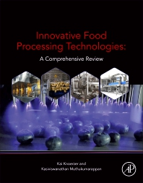
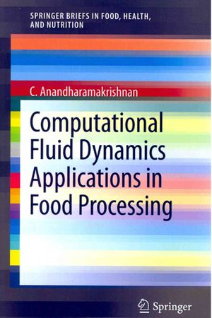
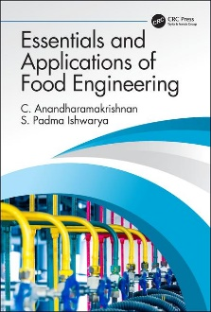

8 Books
&
68 Book chapters

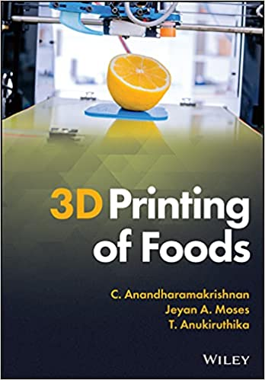
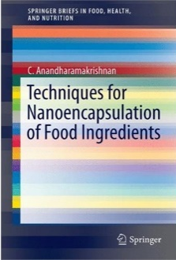
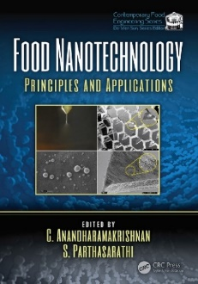
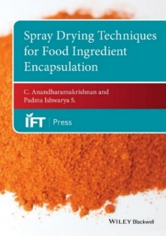

Talks, Technical Committees, Events
This representation provides a summary of talks delivered; events organized etc.

Students Guided/ Mentored

Ph.D. Students Guided (Degree Awarded) - 14
Ph.D. Students (On-going) - 2
Post-docs Mentored/Mentoring - 12
M.Tech. and M.Sc. Students (Degree Awarded) - 30
M.Tech. and M.Sc. Students (On-going) – 2
Under-Graduation (student/student groups) – 20
B.Tech. Students (On-going) – 2 groups

Member in Scientific/Technical/Professional Committees

- Chairman of the technical committee to support committee on capacity building and research for PM-FME scheme constituted by MoFPI-OM dated 13th October 2020.
- Chairman of the technical committee on food products under Production Linked Incentive Scheme (PLI) for food processing industry constitute by Ministry of Food Processing Industries (MoFPI) OM dated 17th June 2021.
- Convener of the committee to appraise common incubation facility proposals from states/Union territories under PM-FME scheme constituted by MoFPI-OM dated 4th January 2021.
- Member of Governing body of the Central Board of Secondary Education (CBSE) (2016-18).
- Member of Scientific Panel on Cereals, Pulses & Legume and their Products (Including Bakery) constituted by Food Safety and Standards Authority of India (FSSAI) (2018-19).
- Inter-Ministerial Expert Committee member to frame guidelines for evaluation of nano based agri and food products in India, Department of Biotechnology, Ministry of Science and Technology, Government of India.
- Member of Expert committee of the MoFPI for considering the R&D proposal to be received under the scheme of research and development in the processed food sector since 13th September 2017.
- Member of Indo-Italy joint working group on food processing, Ministry of Food Processing Industries.
- Expert Member of Agriculture Biotechnology Task Force, Department of Biotechnology, Ministry of Science and Technology, Government of India.
- Member of Monitoring committee for the CSIR Mission mode project “Development of Affordable Technologies for Quality Milk Assessment”.
- Expert member of MSSRF research group formed to study on market infrastructure, value addition and logistics in the context of the larger policy goal of doubling farmer’s income funded by Ministry of Agriculture and Farmers’ Welfare, Govt. of India.
- Member of expert group of CSIR-Mission-Food and Consumer Safety Solutions (FOCUS) since December 2017.
- Member of the panel constituted for formulation of Indian standard on specifications for fortified rice
kernels constitute by Bureau of Indian Standards (BIS), Government of India.
- Chairman for the committee of technical experts to deliberate on the promotion of use of millets in ready to cook (RTC)/ ready to eat (RTE) products constitute by Ministry of Food Processing Industries (MoFPI), Government of India.
- Member of the committee for capacity building and research for PM-FME scheme constituted by MoFPI-OM dated 24th July 2020.
- Co-chairman of expert group on improving agricultural supply chain in North Eastern region constituted by NITI Aayog
- Member, Board of Directors of the Rajmata Vijayraje Sciindia Krishi Vishwa Vidhyalaya – Agri Business Incubation Centre at Gwalior, Madhya Pradesh since October 2020.
- Member of “Research Advisory Committee” at National Institute of Food Technology Entrepreneurship and Management (NIFTEM), Haryana for three years from July 2020 to Aril 2022.
- Member of 'Technical Board' of All India Food Processors Association Journal 'Indian Food Packer'
- Member of India-Denmark Joint Working Group (JWG) on “Food Processing”.
- Member of the Academic Council of Tamil Nadu Agricultural University (TNAU), Coimbatore April 2016-22).
- Member of Project Approval Committee (PAC) of the Ministry of Food Processing Industries (MoFPI) for the component of setting up/upgrading food testing laboratories of the scheme for quality assurance.
- Member of Technical Scrutiny Committee (TSC) of the MoFPI for the component of setting up/upgrading of food testing laboratories of the scheme for quality assurance.
- Member of Board constituted by the Ministry of Health and Family Welfare, Government of India, for selection of food analyst under the provisions of the Food Safety and Standards Act.
- Member of the Research Advisory Board of Tamil Nadu food grains marketing yard, Sikkandarchavadi, Alanganallur Road, Madurai, Tamil Nadu.
- Member of Board of Management of National Institute of Food Technology Entrepreneurship and Management (NIFTEM) since April 2016 to April 22.
- Member Secretary of Board of Management of IIFPT since April 2016 to April 2022.
- Member Convener of Executive committee of IIFPT since April 2016 April 2022.
*******
More details are available at www.anandharamakrishnan.com

